Nancy S. Nurse, RN

65 Some Street, New York, NY 56324
111-111-7890 • job@hunter.com

November 6, 2008

ATTN: Human Resource Manager

Dear Sir or Madam:

Are you looking for someone with a track record of providing excellent patient care, outstanding administrative skills, and everything necessary to be an effective member of your nursing team?

Here is an overview of some of my qualifications and accomplishments:
• Over 8,000 hours of actual hands-on patient care experience.
• In-depth knowledge in administration that includes admissions, assessment, treatment, referral and education for a wide range of patients.
• Countless commendations from the ones who really matter, the patients and families that I have served.
• Awards for dedication, excellent performance, leadership and patient advocacy.

My need to go above and beyond along with an ability to work well under pressure will enable me to make a substantial contribution to your organization. A challenging environment such as yours will provide me with an opportunity to utilize my skills while contributing to the healthcare community, patients and their families.

I have enclosed my resume for your review. I can not wait to discuss with you how my skills and experience make me the ideal fit for this position, you can reach me at 111-111-5455

Sincerely,
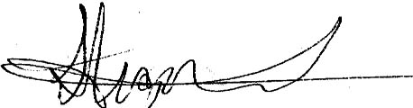
Nancy S. Nurse, RN

